Short-Term Scientific Mission (STSM) Application – Grant Period 2

1. Introduction 2
1.1 Application deadlines for this call 2
1.2 Purpose of a STSM 2
1.3 Eligibility Criteria 2
1.4 Scope of CINNAMON 3
2. STSM application documents 3
3. Application submission via e-COST platform 4
4. Evaluation of applications 5
5. STSM reporting: Scientific Report, and short report for dissemination purposes 5
6. STSM Grant Management 6
7. Main contacts 7
Annex I: Application form template and supporting information template 8
Annex II: e-COST link to STSM report template and short report for dissemination 9

Procedure overview and timeline
- Carefully read this document together with the documents provided through the referenced links.
- Prepare all the required application documents.
- Submit the application via the e-COST platform.
- Upon completion of the STSM, submit the scientific report and additional documentation through e-COST within 30 days after the end of the activity or 15 days after the end of the Grant Period; whichever date comes first.
- Grants are paid by the Grant Holder Institution after the completion of the activity and approval of all required report/documentation

Timeline:

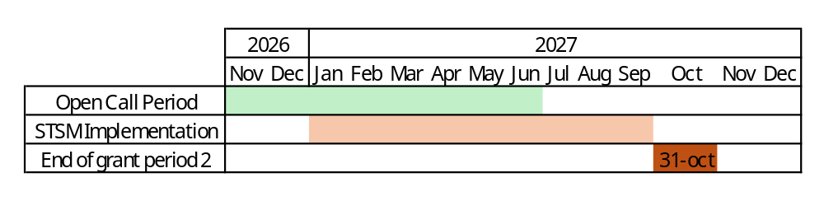

- Introduction

The COST Action CINNAMON opens a call for applications for Short-Term Scientific Missions (STSMs) to be developed under the scope of the referred Action, in the terms described in this document. The call for Grant Period 2 (GP2) will cover 1 November 2026 – 30 June 2027, both days included. The approved STSM must take place between 1 January 2027 and 30 September 2027, both dates included.

Application deadlines for this call

- November 1st 2026 – June 30th 2027: Application call for STSMs opens and applicants can submit their applications throughout this period.
- Evaluation: Applications are approved on a rolling basis
- Notification: Selected candidates will be notified on a rolling basis.
- January 1st 2027 – September 30th 2027: Approved STSM activities can take place during this period and must be completed by 30th September 2027.
Please, find below links to additional information, procedures and regulations concerning STSMs. We recommend applicants to read them carefully before applying for the STSM.
Annotated Rules for COST Actions
Grant Awarding – User Guide

Purpose of a STSM

Short-Term Scientific Missions are visits of a researcher or innovator to a host organization located in a different country than the country of affiliation (for Affiliation, see Article 4.1.1.1.1 on Annotated Rules for COST Actions document) for specific work to be carried out and for a determined period of time. STSMs are valuable:
(i) for the STSM Grantee, who has the chance to receive funding for implementing a project with an international team, obtaining new knowledge or access to equipment or techniques not available in the home institution;
(ii) for the STSM Host who can receive an international partner in their institution and extend or create a long-lasting collaboration. STSMs support specific / general topic(s) that can help achieve the Action MoU objectives and deliverables (research coordination). A STSM should specifically contribute to the scientific objectives of the COST Action, helping to achieve the Action MoU objectives and deliverables.

Eligibility Criteria

The Grant applicant(s) are Action participants with a primary affiliation (see Article 4.1.1.1.1 in the Annotated Rules for COST Actions) to a legal entity located in a COST Full or Cooperating Member country, a COST Near Neighbour Country or a European RTD Organization;
The Grant applicant is a researcher or innovator who visits a host organization located in a different country than the country of affiliation (for Affiliation, see Article 4.1.1.1.1 on Annotated Rules for COST Actions document) for specific work to be carried out and for a determined period of time;
The STSM must have a minimum duration of 5 calendar days (including travel) and be implemented between January 1st 2027 – September 30th 2027.

Scope of CINNAMON

The CINNAMON COST Action is dedicated to expanding, harmonising, and strengthening CAR-T cell therapy expertise across Europe. By linking academic manufacturers, clinicians, researchers, regulators, patient organisations, and industry stakeholders, CINNAMON aims to accelerate innovation, ensure equitable access, and build the foundations for decentralised CAR‑T manufacturing. Our network brings together centres from across Europe and beyond, working collaboratively to share knowledge, develop standards, foster training, and create a robust ecosystem for advanced cellular immunotherapies.
For further details and specific objectives, please read the Memorandum of Understanding (MoU) of CINNAMON COST Action: https://www.cost.eu/actions/CA24115/. Please, note that the STSM should comply with the scope of the Action.

- STSM application documents

The following documents should be submitted:

- STSM Grant Application based on e-COST template. It can be found at https://www.cost.eu/STSM_GrantApplication

- Invitation letter from the Host Institution. It is the responsibility of the applicant to obtain a signed written agreement from the Host institution stating that the applicant may perform the activities detailed in the STSM working plan on the agreed dates. The letter must be dated back not more than 3 months, and must be signed by a permanent staff representative of the Host institution (e.g., head of the research group, PI, director of the department, head of the institute/division etc.)

- Candidate CV

- Supporting information template. See Annex I

- Application submission via e-COST platform

The application procedure is legally bound to the Rules for COST Actions. Eligible STSM applicants must submit their STSM applications online by logging into e-COST (https://e-services.cost.eu) and go to https://e-services.cost.eu/activity/grants and click on “Start a Grant Application”:

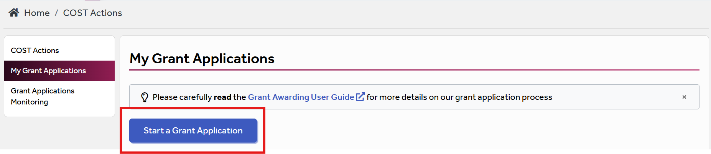

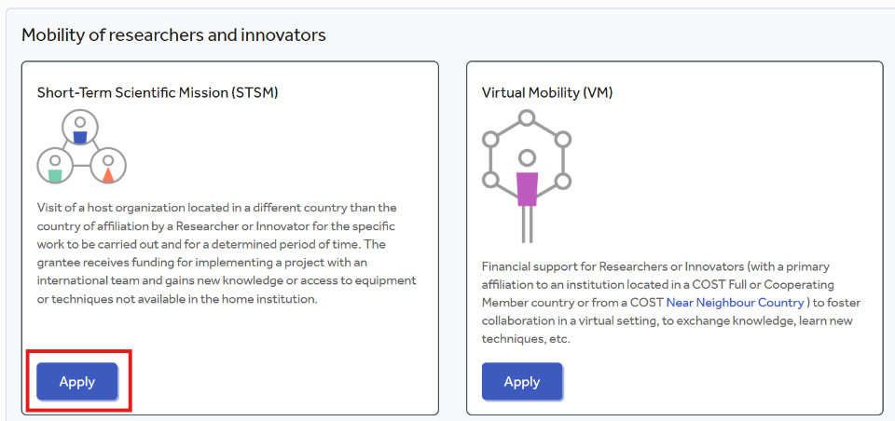
The applicant can select the grant type from the page “Apply for Grant”. Then, to encode a new application, click on “Apply” on “Short-Term Scientific Mission grant”.

And fill the online form with the following information:

- Applicant name
- Primary affiliation
- Type
- COST Action
- Grant Period
- Grant Tittle
- Amount requested
- Bank account
- Start date requested
- End date requested
- Host institution name
- Host institution city
- Host institution country
- Host institution url
- Host contact person name
- Host contact person email

After “Save Draft” the applicant will need to upload further supporting documentation, that includes:
- The completed Grant application template
- Signed Invitation letter from the Host
- CV
- The supporting information template (see Annex I)

Once all the documents have been uploaded, the applicant should click “Submit.” A new window will appear; click on “Options” and then select “Download PDF.”

- Evaluation of applications

The applications will be evaluated on a rolling basis by the Core group of the Action, which is composed of the Grant Awarding Coordinator (Dr. Domas Vaitiekus, domas.vaitiekus@kaunoklinikos.lt) and the leaders of the working groups, among others.

The core group will perform the scientific assessment of the applications considering the CINNAMON Action scope and objectives, as well as the potential for enhancement of the research interaction between the involved parts, measured by the impact of the exchange expected by the applicants and involved institutions.
The selection of applicants is based on the scientific scope of the STSM application which must be coherent with the overall objectives of the Action. The Core Group will select the successful applications. In case of conflict of interest (i.e. the applicant belongs to a commission’s research group), the member that is constrained in their duties will be excluded from the evaluation of the application.

General criteria for evaluation of STSM proposals are:
- Priority to PhD students and post-docs until 4 years after the completion of the PhD;
- Priority to applicants from ITCs;
- Gender balance;
- Territory of origin balance;
- Clarity of activity planning (Working plan) and complementarity of resources between home and host institutions/research groups (resources are intended as: technical expertise, infrastructure, or instrumentation);
- Main expected outputs and their contribution to the progress towards the Action objectives and deliverables;
- Curriculum Vitae (CV)

The Grant Holder Manager will inform each approved applicant by sending a Grant Letter generated from e-COST.

- STSM reporting: Scientific Report, and short report for dissemination purposes

The following documents should be submitted:

- STSM report based on e-COST template. It can be found at https://www.cost.eu/STSM_Report.

- Letter of approval of the STSM report by the Host Institution

- Short report for dissemination purposes, including a picture. We request the applicant to provide additional dissemination information in a separate document (see Annex II).

The STSM report must be approved by the host supervisor and uploaded at the end of the STSM, within 30 days after the end of the activity or 15 days after the end of the Grant Period; whichever date comes first via e-COST platform. Host approval of the scientific report is an official letter or email from a senior Researcher affiliated to the Host institution formally stating the acceptance of the scientific report. Once approved by the host supervisor, the report must be uploaded on e-COST.

The STSM report is drafted by the applicant and should have maximum 4 pages. When preparing the scientific report please consider the following:
- The STSM report for COST is a public document. Please take this into account in terms of Intellectual Property Rights.
- The STSM report does not need to contain specific and detailed results of the research. Rather, it should focus on the aspects that are the aim of STSM, in particular how the collaborative research during STSM has strengthened the scientific relationship between Home and Hosting institutions within the framework of Cooperation and Science in the European Union.

The short report for dissemination purposes should consist of a short success story describing the topic of your collaborative STSM activities, including a strong promotional sentence summarising your experience. Please include your social media profiles (if applicable) to allow tagging, mention both the home and host institutions, and convey your enthusiasm for science. At least one photograph of you at work during the STSM should be provided. This material will be used on the CINNAMON website and social media channels.

Failure to submit the required documents within 30 days from the end date of the STSM or 15 days after the end of the Grant Period, whichever date comes first, will cancel the Grant

By applying for this grant, the participant acknowledges that he/she is aware that his/her data and dissemination material will be collected, stored, processed and used for the purposes of the activities of the CINNAMON COST action CA24115 in accordance with the General Data Protection Regulation (GDPR).

- STSM Grant Management

Applicants must prepare the budget filling the table provided in the supporting information template (see Annex I). Each successful STSM applicant will be granted a sum based on the duration of their stay. We recommend that the requested grant does not exceed 1,000 euros for 1 week and 2,500 euros for one month and has to be duly justified with the excel sheet provided.

*Please note, that in compliance with the Annotated Rules (page 100) the maximum amount that may be reimbursed is up to EUR 4,000 per grant.

An STSM Grant is a fixed financial contribution which takes into consideration the budget request of the applicant and the outcome of the evaluation of the STSM application. Please note that STSM Grants do not necessarily cover all expenses related to undertaking a given mission, being only a contribution to the overall travel, accommodation and meal expenses of the Grantee. Applicants are encouraged to evaluate their budget request based on a high benefit/cost ratio and justify it based on the perceived cost of living in the host country. Applicant should use the template provided in Annex I.

STSM grantees should make their own arrangements for all provisions related to personal security, health, taxation, social security and pension matters.

Grants are paid by the Grant Holder Institution after the completion of the activity and approval of all required report and documentation. Within 30 days from the end date of the STSM (or 15 days after the end of the Grant Period), whichever date comes first, the successful applicant must submit the scientific report, the dissemination report and the approval letter of the scientific report from the Host institution. These documents must be uploaded on e-COST to proceed with the request for payment.

Pre-payment
STSMs grantees may request up to 50% pre-payment of the approved grant. This amount is subject to availability of funds and approval by the Grant Holder Institution. The request of pre-payment shall be submitted to the Grant Holder Manager (Núria Ferrer; nuferrer@recerca.clinic.cat) and the Grant Awarding Coordinator (Domas Vaitiekus; domas.vaitiekus@kaunoklinikos.lt).

- Main contacts

Domas Vaitiekus
Grant Awarding Coordinator
Lietuvos Sveikatos Mokslu Universiteto Ligonine Kauno Klinikos
Lithuania
domas.vaitiekus@kaunoklinikos.lt

Nausika Betriu
Young Researchers and Innovators Coordinator
Fundació de Recerca Clínic Barcelona-Institut d’Investigacions Biomèdiques August Pi i Sunyer (FRCB-IDIBAPS)
Spain
nbetriu@recerca.clinic.cat

Annex I: Application form template and supporting information template

A – Grant Application Template: https://www.cost.eu/STSM_GrantApplication
B – Supporting information template
Select a maximum of 2 Working groups in relation to the project
WG1 – Manufacturing, scale-up, standardization and quality control
WG2 – Preclinical development of novel CAR-T therapies
WG3 – Regulatory affairs and market access
WG4 – Clinical research
WG5 – Public awareness and patient engagement
WG6 – Communication and Dissemination
Budget plan. Applicants must provide a detailed budget to justify the requested grant amount. The budget should be adapted accordingly for shorter or longer stays. Requests must be proportionate to the duration of the mission (e.g. requesting EUR 2,000 for a one-week stay would not be considered appropriate). Please complete the budget in the table below, in the sections labelled as [fill in].

Duration of the STSM in days (including travel days): [Fill in]
Item | Amount (per day) (€) | Total amount (€)
Estimated travel costs | - | [Fill in]
Estimated accommodation costs | [Fill in] | [Fill in]
Estimated meals cost | [Fill in] | [Fill in]
Estimated local transport costs | [Fill in] | [Fill in]
Other costs (*) | [Fill in] | [Fill in]
Total |  | [Fill in]

Total Grant amount requested: [Fill in] €

(*) Other cost justification (if applicable): [Fill in]

Intellectual Property Rights concerns. In case of potential intellectual property concerns, by the host and/or home institutions, must be mentioned below and managed by IP teams from host and/or home institutions. In this case the reviewers of the application may be requested to sign a confidential agreement. If no IP concerns apply, please mention in your application that there are no IP concerns.

Annex II: e-COST link to STSM report template and short report for dissemination

A – STSM Report template: https://www.cost.eu/STSM_Report
STSM Report has to be uploaded to e-COST within 30 days after the end of your STSM or 15 days after the end of the Grant Period, whichever date comes first.

B – Short report for dissemination purposes
Dissemination information must be sent to Domas Vaitiekus (domas.vaitiekus@kaunoklinikos.lt), Maria Klapa (mklapa@iceht.forth.gr) and Nausika Betriu (nbetriu@recerca.clinic.cat). It should include the following:
- Short success story (3-4 sentences)
- At least one picture of the grantee in the host lab/institution (add a caption)
- Credentials in social media (LinkedIn), if applicable

Failure to submit the STSM report and dissemination materials, and Host acceptance of the Report within 30 days from the end date of the STSM or 15 days after the end of the Grant Period, whichever date comes first, will effectively cancel the Grant.

