Young Researcher and Innovator (YRI) Conference Grant Application – Grant Period 2

1. Introduction 2
1.1 Application deadlines for this call 2
1.2 Purpose of a YRI Conference Grant 2
1.3 Eligibility Criteria 2
1.4 Scope of CINNAMON 3
2. YRI Conference Grant application documents 3
3. Application submission via e-COST platform 3
4. Evaluation of applications 4
5. YRI Conference Grant reporting: Scientific Report, and short report for dissemination purposes 5
6. YRI Conference Grant Management 6
7. Main contacts 6
Annex I: Application form template and supporting information template 7
Annex II: e-COST link to YRICG report template and short report for dissemination 8

Procedure overview and timeline
- Carefully read this document together with the documents provided through the referenced links.
- Prepare all the required application documents.
- Submit the application via the e-COST platform.
- After attending the conference, upload on e-COST the required reports/documents within 30 days after the end of the YRICG. Grants are paid by the Grant Holder Institution after the completion of the activity and approval of all required report/documentation

Timeline:
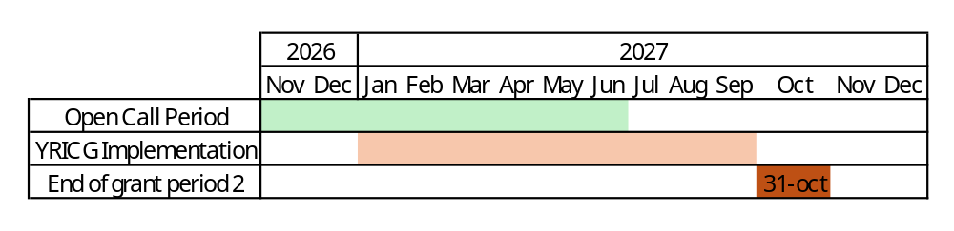

- Introduction

The COST Action CINNAMON opens a call for applications for YRI Conference Grants to be executed under the scope of the referred Action, in the terms described in this document. The application call for Grant Period 2 (GP2) will cover 1 November 2026 – 30 June 2027, both days included. The approved conference attendance must take place between 1 January 2027 and 30 September 2027, both dates included.

Application deadlines for this call

- November 1st 2026 – June 30th 2027: Application call for YRI Conference Grant opens and applicants can submit their applications throughout this period.
- Evaluation: Applications are approved on a rolling basis
- Notification: Selected candidates will be notified on a rolling basis.
- January 1st 2027 – September 30th 2027: Approved YRI Conference Grant activities can take place during this period and must be completed by 30th September 2027.
Please, find below links to additional information, procedures and regulations concerning YRICG. We recommend applicants to read them carefully before applying.
Annotated Rules for COST Actions
Grant Awarding – User Guide

Purpose of a YRI Conference Grant

YRI Conference Grant (YRICG) funds a presentation (poster/oral presentation) of the grantee’s own work within the scope of the Action by a Young Researcher and Innovator (YRI) in a high-level conference fully organized by a third party, i.e. not organized nor co-organized by the COST Action.
- Serves COST Excellence and Inclusiveness Policy;
- Supports YRI to establish a strong network and increase their visibility in the research community through sharing their work and to gain knowledge;
- Can contribute to increasing visibility of the Action.
YRI Conference grant benefit YRI Conference Grantee, by providing financial support for attending and presenting their own work within the scope of the Action (poster/oral presentation) in a conference, while also enabling them to establish new contacts and foster future research collaborations. YRICG provides a contribution for travelling, accommodation and subsistence expenses, registration fee, printing of scientific poster and overall effort.

Eligibility Criteria

The Grant applicant(s) are CINNAMON participants with a primary affiliation (see Article 4.1.1.1.1 in the Annotated Rules for COST Actions) to a legal entity located in a COST Full or Cooperating Member country, a COST Near Neighbour Country or a European RTD Organization; The applicant(s) must be YRIs aged below 40 years; The conference must take place between January 1st 2027 – September 30th 2027.

Scope of CINNAMON

The CINNAMON COST Action is dedicated to expanding, harmonising, and strengthening CAR-T cell therapy expertise across Europe. By linking academic manufacturers, clinicians, researchers, regulators, patient organisations, and industry stakeholders, CINNAMON aims to accelerate innovation, ensure equitable access, and build the foundations for decentralised CAR‑T manufacturing. Our network brings together centres from across Europe and beyond, working collaboratively to share knowledge, develop standards, foster training, and create a robust ecosystem for advanced cellular immunotherapies.
For further details and specific objectives, please read the Memorandum of Understanding (MoU) of CINNAMON COST Action: https://www.cost.eu/actions/CA24115/. Please note that the conference attended must fall within the scope of the Action.

- YRI Conference Grant application documents

The following documents should be submitted:

- Grant Application based on e-COST template. It can be found at https://www.cost.eu/YRICG-application-template
- Acceptance (or invitation) letter from the conference organisers
- Copy of the abstract of the accepted oral or poster presentation
- Candidate CV
- Supporting information template. See Annex I

- Application submission via e-COST platform

The application procedure is legally bound to the Rules for COST Actions. Eligible applicants must submit their application online by logging into e-COST (https://e-services.cost.eu) and go to https://e-services.cost.eu/activity/grants and click on “Start a Grant Application”:

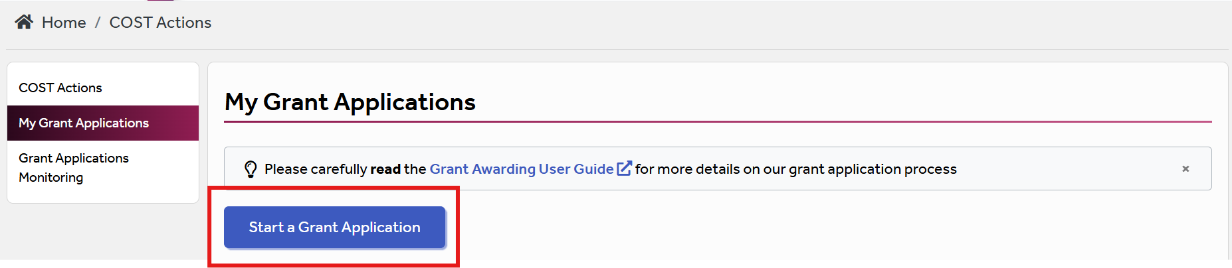

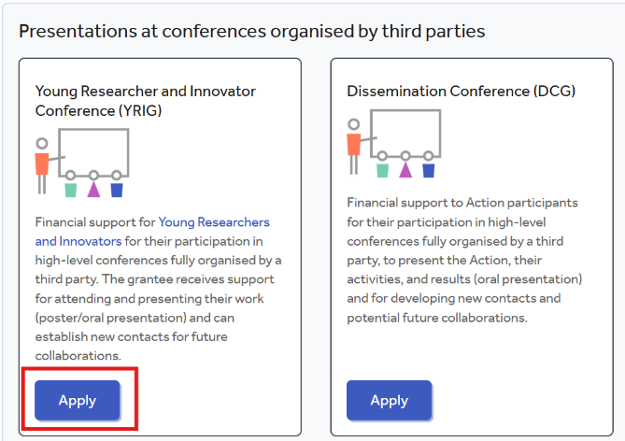
The applicant can select the grant type from the page “Apply for Grant”. Then, to encode a new application, click on “Apply” on “YRI Conference”:

And fill the online form with the following information:

- Applicant name
- Primary affiliation
- Type
- Attendance Type (face to face / online)
- COST Action
- Grant Period
- Grant Title
- Amount requested
- Bank account
- Start date requested
- End date requested
- Conference title
- Conference country
- Conference url

After “Save Draft” the applicant will need to upload further supporting documentation, that includes:
- The completed Grant application template (https://www.cost.eu/YRICG-application-template)
- The acceptance (or invitation) letter from the conference organisers
- Copy of the abstract of the accepted oral or poster presentation
- CV
- The supporting information template (see Annex I)

Once all the documents have been uploaded, the applicant should click “Submit.” A new window will appear; click on “Options” and then select “Download PDF.”

- Evaluation of applications

The applications will be evaluated on a rolling basis by the Core group of the Action, which is composed of the Grant Awarding Coordinator (Dr. Domas Vaitiekus, domas.vaitiekus@kaunoklinikos.lt) and the leaders of the working groups, among others.

The core group will perform the scientific assessment of the applications considering the CINNAMON Action scope and objectives, as well as the potential for enhancement of the research interaction between the involved parts, measured by the impact of the exchange expected by the applicants and involved institutions.
The selection of applicants is based on the scientific scope of the conference to attend, which must be aligned with the overall objectives and scope of the Action. The Core Group will select the successful applications. In case of conflict of interest (i.e. the applicant belongs to a commission’s research group), the member that is constrained in their duties will be excluded from the evaluation of the application.

General criteria for evaluation of YRI Conference Grant proposals are:
- Applicants must be under 40 years old;
- Gender balance;
- Country balance;
- Quality of the abstract of the oral or poster presentation
- Main expected outputs and their contribution to the progress towards the Action objectives and deliverables;
- Curriculum Vitae (CV)

The Grant Holder Manager will inform each approved applicant by sending a Grant Letter generated from e-COST.

- YRI Conference Grant reporting: Scientific Report, and short report for dissemination purposes

The following documents should be submitted:

- YRI Conference Grant report based on e-COST template. It can be found at https://www.cost.eu/YRICG-report-template
- The certificate of conference attendance issued by the conference organiser.

- The programme of the conference or book of abstracts / proceedings indicating the presentation (oral or poster) of the grantee.

- Copy of the given oral or poster presentation

- Short report for dissemination purposes, including a picture of the applicant at the conference. In addition, applicants are requested to provide further dissemination materials in a separate document (see Annex II).

The report must be uploaded to the e-COST platform within 30 days after the end of the conference. The following should be considered:

- The report for COST is a public document. Please take this into account in terms of Intellectual Property Rights.

- The report should focus on the networking aspects, in particular how contacts for future collaborative research have been managed to strengthen the scientific relationship between the grantee and other people present at the conference within the framework of Cooperation and Science in the European Union.

The report for dissemination purposes should consist of a brief success story describing your experience at the conference. Applicants are encouraged to convey their enthusiasm for science and, where applicable, provide links to their social media profiles to facilitate tagging and dissemination activities. At least one photograph of the applicant at the conference must be included. This material may be used for communication and dissemination purposes through the CINNAMON website and social media channels.

Failure to submit the required documents within 30 days following the end of the conference will result in the cancellation of the Grant.

By applying for this grant, the participant acknowledges that he/she is aware that his/her data and dissemination material will be collected, stored, processed and used for the purposes of the activities of the CINNAMON COST action CA24115 in accordance with the General Data Protection Regulation (GDPR).

- YRI Conference Grant Management

- Applicants must prepare the budget filling the table provided in the supporting information template (see Annex I). Each successful YRICG applicant will be granted a sum based on the duration of their stay, of maximum 2,500 EUR.

- An YRICG is a fixed financial contribution which takes into consideration the budget request of the applicant and the outcome of the evaluation of the application. Please note that YRICG do not necessarily cover all expenses related to undertaking a given mission, being only a contribution to the overall travel, accommodation and meal expenses of the Grantee. Applicants are encouraged to evaluate their budget request based on a high benefit/cost ratio and justify it based on the perceived cost of living in the host country. Applicant should use the template provided in Annex I.

- YRICG grantees should make their own arrangements for all provisions related to personal security, health, taxation, social security and pension matters.

- Grants are paid by the Grant Holder Institution upon completion of the activity and approval of all required reports and supporting documentation. Within 30 days following the end date of the conference, the successful applicant must submit all required documents. These documents must be uploaded to the e-COST platform in order to initiate the payment process.

- Main contacts

Domas Vaitiekus
Grant Awarding Coordinator
Lietuvos Sveikatos Mokslu Universiteto Ligonine Kauno Klinikos
Lithuania
domas.vaitiekus@kaunoklinikos.lt

Nausika Betriu
Young Researchers and Innovators Coordinator
Fundació de Recerca Clínic Barcelona-Institut d’Investigacions Biomèdiques August Pi i Sunyer (FRCB-IDIBAPS)
Spain
nbetriu@recerca.clinic.cat

Annex I: Application form template and supporting information template

A – Grant Application Template: https://www.cost.eu/YRICG-application-template
B – Supporting information template
Select a maximum of 2 Working groups in relation to the project
WG1 – Manufacturing, scale-up, standardization and quality control
WG2 – Preclinical development of novel CAR-T therapies
WG3 – Regulatory affairs and market access
WG4 – Clinical research
WG5 – Public awareness and patient engagement
WG6 – Communication and Dissemination
Budget plan. Applicants must provide a detailed budget to justify the requested grant amount. Requests must be proportionate to the duration of the stay. Please complete the budget in the table below, in the sections labelled as [fill in].

Duration of the stay in days (including travel days): [Fill in]
Item | Amount (per day) (€) | Total amount (€)
Estimated travel costs | - | [Fill in]
Estimated accommodation costs | [Fill in] | [Fill in]
Estimated meals cost | [Fill in] | [Fill in]
Estimated local transport costs | [Fill in] | [Fill in]
Other costs (*) | [Fill in] | [Fill in]
Total |  | [Fill in]

Total Grant amount requested: [Fill in] €

(*) Other cost justification (if applicable): [Fill in]

Annex II: e-COST link to YRICG report template and short report for dissemination

A – Report template:
https://www.cost.eu/YRICG-report-template
The YRICG Report has to be uploaded to e-COST within 30 days after the end of the conference.

B – Short report for dissemination purposes
Dissemination information must be sent to Domas Vaitiekus (domas.vaitiekus@kaunoklinikos.lt), Maria Klapa (mklapa@iceht.forth.gr) and Nausika Betriu (nbetriu@recerca.clinic.cat) within 30 days after the end of the conference.
It should include the following:
- Short success story (3-4 sentences)
- At least one picture of the grantee at the conference (add a caption)
- Credentials in social media (LinkedIn), if applicable

Failure to submit the report and dissemination materials within 30 days from the end date of the conference will cancel the Grant.

